SHOPPERS SACCO LTD
BIG DATA SOLUTION FOR
CUSTOMER SURVEY ANALYSIS.

Patrick Steve Adera.
Park University.
Prof. Andrew Sallee
12/11/2022.

TABLE OF CONTENTS
1 PROBLEM STATEMENT 3
2 PROJECT SCHEDULE 3
3 InFORMATION SYSTEMS PROPOSAL 4
4 CODE TO ACQUIRE AND/ OR PROCESS DATA 6
5 DATA SOURCES AND DATA FLOW DIAGRAMS 7
6 Ethical Implication, Risk, and Security Assessment Statement. 10
7 Database Design 13
8 Data Analysis and Visualization Report 17
Appendix 1: The CSS Architectural Design 22
APPENDIX 2: MongoDB 22
APPENDIX 3. DATA FLOW DIAGRAM 23
9 References 24

PROBLEM STATEMENT
Shoppers Sacco Society Ltd is a mid-size financial institution operating in Kenya, with its head office located in Nairobi- East Africa’s economic hub. It has several other offices situated in major cities across the country. The Sacco’s main business activity is to mobilize savings and issue loans to its members. Besides that, it provides overdraft facilities, salary processing services, dividend processing, standing order processing, and check processing, among others.
The Sacco has in recent years faced a decline in membership acquisition and retention, a decline in loan uptake, and an increase in the number of defaulted loans. This has in turn led to a decrease in its asset portfolio, which once stood in the billions. As this has been happening, majority of the main players in the industry (direct or indirect competitors) have been thriving. Despite the management’s effort to change this trajectory by adopting new business strategies, offering membership incentives, relaxing some of the strict policies that have been in place, etc., nothing seems to be generating the desired change. It is evident that these decisions are not made from a factual and analytical standpoint and that there are other underlying issues that the Sacco is yet to identify.

PROJECT SCHEDULE
Week | Deliverable(s) from List
2 | Information systems proposal
3 | Data sources and data-flow diagram
4 | Ethical implication, risk, and security assessment statement
5 | Database design
6 | Code to acquire and/or process data
7 | Data analysis and data visualization report

InFORMATION SYSTEMS PROPOSAL
My proposal is for the incorporation of big data and analytics into the Sacco’s decision-making process. Big data is a combination of structured, semi structured, and unstructured data of increased complexity that warrants the use of more robust computational resources to capture, manage and process. As things are, the Sacco is unable to adequately capture and analyze customer data and derive meaningful and actionable insights from it.
There exists valuable and very insightful information in the form of customer feedback that remains untapped. Some of the issues the Sacco is facing like the decline in membership or decline in loan uptake can very easily be solved by opening customer feedback channels. As part of my proposal, I advocate for the development of a Customer Survey Information System (CSS) that gathers feedback from members on all matters relating to their experience, products, satisfaction levels, customer service, technology use, and sentiments, among others. This feedback system should be integrated with the existing application software (internal business data) to fully take advantage of all the data available to the Sacco. ‘This data can help in evaluating the Sacco’s historical performance, discover new opportunities, identify operational inefficiencies, increase customer satisfaction, and even predict likely outcomes for the future.’ (Microsoft, 2016).

Customer feedback data can be obtained in two ways:
- By using the CSS to send survey questions to customers immediately upon completion of a transaction. The CSS solution automatically triggers a survey through text messages, emails, or phone calls. Customers are provided a link through which they can fill an online survey form and rate the service they just received. This data is captured and stored in the Azure Cosmos DB, a cloud-based document database.
- By using Microsoft Azure HDInsight’s interactive data ingestion tools such as the Microsoft Azure Storage Explorer to collect and load data directly from the Sacco’s social media platforms by use of scripts or command line tools. These scripts can retrieve data using API keys from the social media platforms the Sacco is signed on. Microsoft Azure HDInsight is a cloud distribution of Hadoop components that makes it easy, fast, and cost-effective to process massive amounts of data in a customizable environment. (Microsoft, 2022). It is also responsible for performing the ETL (Extract, transform, and Load) operations on unstructured or semi-structured data to generate data in the familiar relational database format that can then be imported into a database table or a data warehouse. The figure in appendix 1 is an architectural overview that shows the major components in this solution and how they relate.
The focus in this project will however be on the aspect of developing the Customer Survey Information system (CSS) and the analysis of data obtained from this solution.

CODE TO ACQUIRE AND/ OR PROCESS DATA
The proposal is to use Microsoft azure’s cloud storage as the primary host database for the customer feedback solution. This choice was mainly influenced by azure’s robust features that support real-time and big data analytics such as the HDInsight which enables users to use open-source frameworks such as Hadoop, Apache spark, Apache storm, etc., to process large volumes of data.
However, azure only provides a limited amount of time to use their free services (30 days) after which you have to pay a subscription fee. For purposes of creating a proof of concept for this project, I have used MongoDB which provides an alternative cloud based, NoSQL database solution, that also supports map reduce queries for querying large volumes of data. MongoDB atlas provides a small-scale development environment with limited configuration options for an unlimited amount of time, and hence suits this project’s needs.
To begin with, I had to create a database in MongoDB and uploaded a few data items before being able to query it to retrieve data from it. Ordinarily this step will be automated as data will be stored to the cloud database as soon as it is received from the customer. Appendix 2 shows a snapshot of the database created in MongoDB.
The find () syntax is used to retrieve data from the database:
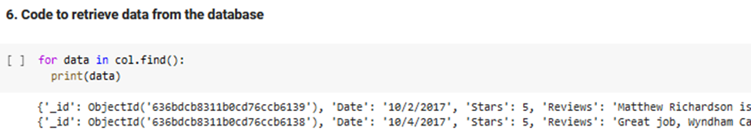
The first data preprocessing step I took is to convert the data into a Pandas DataFrame in what is called the normalization process. This makes it easier to work with the data. Data is stored in MongoDB in JSON format. Secondly, I checked for any duplicates and missing values in the dataset which may cause the analysis to produce inaccurate results. The results of these two tests show the dataset is clean and hence no further data preprocessing is needed to have it ready for analysis and modeling.
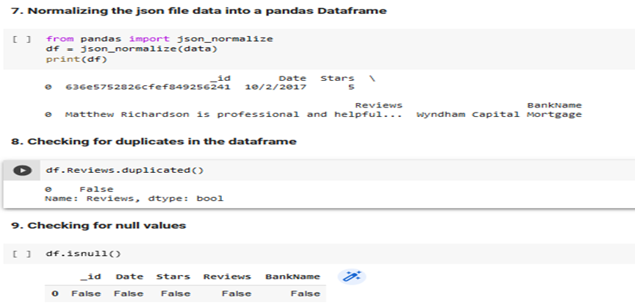

DATA SOURCES AND DATA FLOW DIAGRAMS

The holistic design of the Customer Survey IT Solution (CSS) takes into account the various touchpoints and different ways the customer engages with the Sacco throughout his/her customer journey. Data collection at these touchpoints is important as it enables the organization to gain valuable insights into the customers’ needs and expectations. The following are some of the data sources that can be used to acquire customer feedback:
- Direct data sources – Includes all data sources where there is a direct interaction between the customer and the organization. Examples include phone calls, text chats, Surveys, e-mails, etc. This will be the focus in this project- to use customer surveys to collect precise and deliberate information from the customer regarding products and services the Sacco is offering.
- Indirect data sources – These are third party data sources such as data from websites, social media platforms, customer pages, and review sites. Social media listening is one of the best tools the Sacco can use to gather a wealth of customer experience data and get valuable insights into their needs. (Repustate, 2021). This is because people have growingly become dependent and ‘addicted’ to social media as a means of sharing information, voicing opinions, entertainment, news, marketing, etc.
- Inferred data sources – This is where data collected from websites, web pages, competitor data, etc. is used to determine behavior and infer customer sentiment. A good example is the analysis of visitors who go to the Sacco’s website and spend time on it but do not apply for any loan products or apply for membership to join the Sacco. This can be assumed to mean the Sacco is not offering attractive loan products that could interest the customer or that there are certain joining obstacles the potential clients face.
Direct Data sources in the CSS Solution: The proposed Customer Survey IT Solution (CSS) is designed to integrate seamlessly with the Orbit-R Information System in use at the Sacco as illustrated in the figure in appendix 3. This integration is important in obtaining a visibility in the customer experience and its impact on the business. Once the customer completes a transaction, such as an ATM withdrawal, or funds transfer, or loan disbursement, a trigger is sent from the Orbit-R information system to the CSS for the creation of an interaction record in the database. Thereafter, a survey is triggered by the CSS, and an evaluation form sent to the customer to obtain his/her response. This can be sent through an e-mail, or a text message. The customer receives a link that directs him/her to an online form where he/she fills and submits the feedback which is saved in the database. Alternatively, the survey questions can be relayed through an automated phone call. Here is an example of an online customer satisfaction evaluation form:
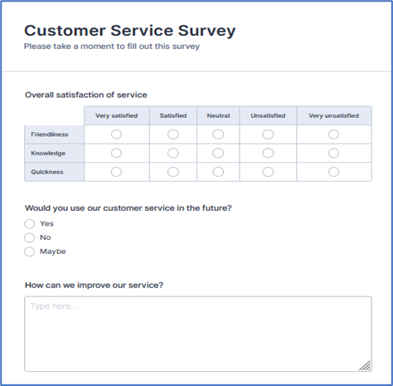
Feedback analysis. Once the feedback is received, a sentiment analysis is carried out using the Machine Learning’s Natural Language Processing model trained using pre-existing data to determine whether the feedback is positive or negative. Negative feedbacks are sent to support agents for follow up and to offer further assistance to the customer. Positive feedbacks are only stored for further analysis to identify the things the customers like about their interaction with the Sacco. The process of sentiment analysis can be automated once the model is developed. Here, time is of essence. The goal is to have customer issues addressed within the minimum time possible to improve the dwindling satisfaction levels recently witnessed in the Sacco. The business problem the Sacco has been facing is a decline in its membership, hence this will go a long way in regaining the customers’ trust and loyalty.

The input-output of the data analysis process consists of the following three components:
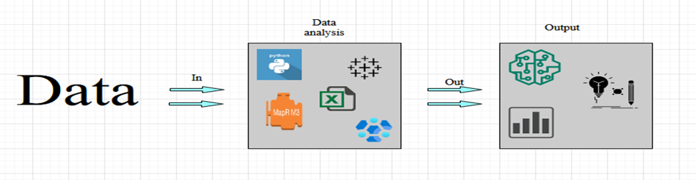
The clean data is passed through data analysis tools such as python, tableau, excel, Azure HDInsight’s Hadoop tools, etc. to produce reports, charts, and machine learning models that can be used to obtain insights as to what the customers’ needs and wants are.

Ethical Implication, Risk, and Security Assessment Statement.
A risk is the probability that a negative event will occur as a result of internal or external vulnerabilities, leading to financial loss, damage of property, or injury to personnel in the company. The goal in this project is to develop a Customer Survey IT Solution that can be used to gather customer feedback for analysis, augmenting other Big Data sources such as social media data, which constitute the overall Sacco Business Intelligence solution. The architectural design of this project greatly relies on cloud infrastructure for data storage and analysis, which increases the exposure to risks.
Cybersecurity risk is one of the greatest challenges the Sacco is likely to face. The use of a cloud architecture implies that the internet will be used on numerous occasions to transfer data and information. This can be easily intercepted by hackers or other actors leading to the loss of confidential data and personal customer information. For instance, vendors supplying the Orbit-R system used by the Sacco for internal processes may lose proprietary information, trade-secrets, or any other sensitive information in the event of a cyber-attack. Customers can also be adversely affected when their personally identifiable information is stolen or other information like credit card information lands in the hands of the wrong people. The Sacco too will not be spared in the event of such an attack. Information pertinent to its ability to derive economic value such as its financial condition, systems, and methods of doing business, or trade agreements may be disclosed, leading to loss of its competitive advantage and an increase in negative public opinion. For these reasons, the Sacco will have to be vigilant in the manner it uses and protects data. Some measures that can be taken include data encryption, use of robust anti-malware software, multi-factor authentication, and choosing a cloud provider with strong, state-of-the-art cloud security.
Downtime. The Sacco risks having downtime periods resulting from technical problems such as network outages and reboots. This can incapacitate business operations and processes and damage the already dwindling Sacco reputation. A downtime implies the Sacco members will not be able to access their funds, causing them a lot of inconvenience especially when the downtime occurs when one is in the process of making a purchase or using an ATM service. Reliability and availability of services is one aspect the Sacco has to pay good attention to. Having local backup servers can help the Sacco keep their essential services alive and maintain some level of business functionality until the cloud service is restored.
Survey fatigue. As much as surveys have over the years produced great results in revealing useful insights into customers’ feelings and sentiments about organizations they do business with and steered the formulation of strategies to improve the processes and services offered, this may not always be the case. Some customers may not appreciate the intentions of these surveys and view it as a nuisance. Survey fatigue is a lack of interest in participating in a survey because it is complex, boring, or long. To be honest, sometimes it becomes too much to have to reply to text or phone call surveys each time you visit your local ATM. Customers should be given the option to opt out of such surveys otherwise they may get more aggravated especially when they already have a negative opinion about the Sacco.
Selling products under the guise of surveys. Paul, 2002 in his article How Surveys Influence Customers also notes that it is ‘ethically dubious, and illegal to sell under the guise of conducting market research.’ He suggests the use of introductory statements like “We’d like to ask you a few questions about your satisfaction with our products and services and tell you about other products you may be interested in.” This makes it clear and well known to the customer that the purpose of the survey is to seek their opinion about the products and services they just received, as well as suggest other products the Sacco is offering.
Noncompliance with regulatory frameworks. Lastly, there is a risk of privacy violation due to noncompliance with regulatory frameworks such as those set out in the General Data Protection Regulation (GDPR) that requires that personally identifiable information collected from citizens of the EU be pseudonymized to protect their identity. The Sacco collects customer feedback and integrates it with other data from internal processes for analysis. Such data may contain sensitive information that should be protected otherwise the Sacco risks violating the regulations set out to govern the practice around sensitive data and privacy protection, which can lead to possible legal suits.

Database Design
The success of this project relies greatly on Microsoft Azure’s big data capabilities to acquire, transform, process, store, and analyze large or complex data. Data sources as stated in the earlier sections of this project include data from the core application software, survey data, and data retrieved from websites and social media pages. Traditional RDMS systems are not well suited for the processing and storage of such data. For this reason, I opted to use a NoSQL database that offers a way to work more freely with data and provide a high degree of flexibility and simplicity. (Mehdi, 2022).
Role of the database. The acquisition, storage, and analysis of the customer survey data is the primary focus of this project. This data includes information such as the date, the branch name, the ratings, and the customer review comments. The customer review comments are of particular interest since they contain pertinent information regarding the customers’ experience with the Sacco. It forms the basis of the analysis; to determine whether the customer is satisfied or not, and the reason(s) for his/her dissatisfaction. The process begins when an evaluation form is sent to a customer upon completion of a transaction. This can be through of a link to an online form that is filled and submitted or automated text messages that ask deliberate questions about certain areas of interest. To deliver a real-time solution, data streaming technologies like Apache Kafka will have to be integrated with the various data sources for data to be ingested directly into the data lake.
Rationale for tools used. The option for implementing this storage includes the use of the Azure Data Lake Store which is a repository for holding large amounts of data in its native, raw format, and the Azure Cosmos DB which is a cloud-based document database. A complete data lake solution consists of both storage and processing. The processing engines transform the raw data ingested into the data lake into a structured query-able format using an ELT pipeline (Extract, Load, Transform). The transformed data is then sent to the database. The database uses an object storage to store the data with metadata tags and unique identifiers, making it easy for analysts and other users to locate, retrieve, and explore the data. Some of the tools and technologies that can be useful in the exploration of the data include the Azure HDInsight and Data Lake Analytics. The Apache Kafka is another tool that can be useful for data streaming.
Design Description and Diagrams. Far from the misconception that NoSQL databases are schema-less for data modelling, design is of out-most importance in describing how the data will be organized in the database. Schema-less design is not to say schema is not used at all, but rather there is high flexibility in the schema design. This schema is usually defined by the application model. The major departure from the traditional RDMS that are designed for storage optimization is that NoSQL databases are designed for access, and hence follow a ‘Query Driven Design.’
There are several types of NoSQL databases: Document databases, Key-value stores, Wide-column databases, and Graph databases. Regardless of the database type chosen, data modelling and schema design are important concepts in any application. In this project, the document database will be the most suitable since it provides a structure for storing data in XML, JSON or BSON formats. Instead of tables and rows, NoSQL document-based uses collections and documents, each document is a single JSON file.
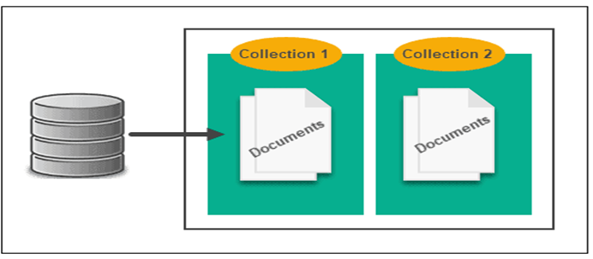
The document database is similar to a key-value stores database in that the records are identified with unique keys and corresponding values. “Each document is effectively an object containing attribute metadata along with a typed value such as string, date, binary or an array.” (Akshay, 2018). The transformed data from the data lake once fed into the Azure Cosmos Database, is converted and stored in JSON format. Below is an illustration of how the data will be stored:
Key | Document
1001 | {  “Date”: “10/4/2017”,  “Stars”: 5,  “Reviews”: “Best loan officer I could have hoped for! Jeff exceeded my expectations. He worked very hard to get me the best rate possible. Highly recommended”,  “BranchName”: “Wyndham Capital Mortgage”  }
1002 | {  “Date”: “7/10/2016”,  “Stars”: 5,  “Reviews”: “Great website, knowledgeable, responsive, and always got back to us quickly with answers to our questions. Mortgage process can be very tedious, and they made it easy.”,  “BranchName”: “North American Savings Bank”  }

Data Modelling. Some document databases create the document keys automatically while others allow users to specify an attribute of the document to use as the key. Data modelling in Azure Cosmos DB can be done in the following ways:
- Embedding – this is where all the entities are treated as self-contained items represented in single JSON documents. Retrieving data from the database then becomes a single read operation against a single container for a single item. Updating the records is also done as a single write operation against a single item. This approach is mainly used where:
- There are contained relationships between entities
- One-to-few relationships between entities
- Data changes frequently
- Embedded data is frequently queried together
- Referencing- this is similar to normalization in SQL. It is useful where information in one document relates to data in other documents. It is also suitable for ‘one-to-many relationship entities where the child documents can grow above the limit or where the data might change frequently’. (Geetcloud, 2021).
- Hybrid- this model combines both worlds of the embedded data models and the referencing data models. It has the advantage of a ‘simpler application logic with fewer server round trips while still maintaining a good level of performance.’ (Microsoft, 2022).
- Document types – in this case multiple, related documents are stored in the same collection with unique identifiers to easily differentiate them.

Data Analysis and Visualization Report
Goals of the analysis. This is an analysis of the customer survey data obtained from Kaggle depicting data from the proposed Customer Feedback Information System. The main objective of this analysis is to find out whether customers are happy with the products and services they are receiving from the Sacco, and if not, what are the reasons for their dissatisfaction. The management would also like to scale this analysis down to the branch level, to figure out which branches are contributing the most in terms of the number of negative feedbacks. This would be helpful in solving some of the issues that are not product related.
Study questions. Most of the study questions in this analysis revolve around the level of product and service satisfaction. The business problem the Sacco is facing is a decline in its membership, which in turn has contributed to a decline in its loan portfolio and the overall asset base. Some of the questions this analysis is seeking to answer include: How satisfied are the customers with the Sacco’s products and services? Did the customers find the right product for their needs? Can the customer recommend the Sacco to family and friends? How easy or fast is it for the customer get help for the Sacco staff? The answers to these questions are assumed to be the determining factor as to whether a customer gives a negative or positive review. For some reason, the dataset used in this analysis only has two ratings, a 1-star rating to indicate negative review and 5 -star rating to indicate a positive review and hence the assumption is that there are no neutral reviews.
It is also important to note that the dataset used in this analysis is from a bank setup and not actual data from the Sacco, hence certain information like branch name may suggest a bank and not a Sacco.
Models. To carry out this analysis, I used the machine learning’s Natural Processing Language (NPL) to develop a model that is able to carry out a sentiment analysis of a customer’s feedback and predict whether the review is positive or negative. My tool of choice for the analysis is python, and I was able to apply the Bag of Words model, and the Naïve Bayes algorithm to develop a machine learning model that can extract features from text and classify sentiments based on learned experience.
Methods. Two methods have been applied in this analysis:
i. Descriptive analysis to ‘describe, show or summarize data points in a constructive way such that patterns might emerge that fulfill every condition of the data.’ (Rawat, 2021). To achieve this, I used tableau to summarize data in a meaningful way and build simple visualizations that can help decision makers better understand the data.
ii. Prescriptive analysis by use of machine learning algorithms to develop a model that is able to learn from existing data and make predictions about future outcomes.
Results. The following are the results of the analysis:
Analysis 1: Tableau The dashboard attached with this paper shows a plot of three graphs – plot of the percentage of positive and negative reviews, plot showing the yearly percentage of positive and negative reviews, and plot showing the percentage of reviews received by each branch. From the first graph (pie chart) it is clear that an overwhelming majority of the customers are happy with the products and services they receive (80.10%). A comparison of the year 2017 from 2016 in the second graph shows there was a slight increase in the percentage of negative (20% from 18.52%) and consequently a decrease in positive reviews (80% from 81.48%). This may signal a lack of action on the customer issues raised in the previous year which may lead to fatigue.
This analysis can be further scaled down to the branch level as shown in graph 3. It is notable that the North American Saving branch over the three years of analysis received the highest percentage of negative feedback (8.06%). The loanSnap and the Truimph Lending branches did not however receive any negative ratings over the same period.
Conclusion. From the results of this analysis, we can conclude that majority of the Sacco customers are satisfied with the products and services the Sacco is offering. However, there are a few customers who are unhappy, and could be on their way out of the Sacco, influencing others to leave with them. The Sacco management should take their feedback seriously and move with speed to take corrective measures to address these issues. It is also important to carry out further investigation as to why the North American Saving bank has the highest number of negative reviews.
Analysis 2: Python The following are the major steps I followed in performing this analysis:
- Importation of the dataset and essential python libraries used in the analysis such as pandas, numpy, and matplotlib.pyplot used for plotting of graphs.
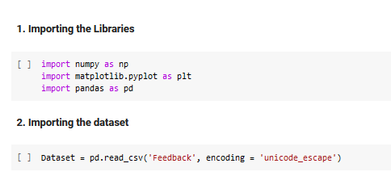
- Cleaning the dataset and creating a bag of words. Additional data cleaning libraries are needed such as re and nltk for downloading the ensemble of ‘stopwords’, which are words not needed in helping the prediction. The CountVectorizer class from sklearn.feature_extraction.text module is another important library used when creating the bag of words by extracting the most frequently used words from the customer review data.
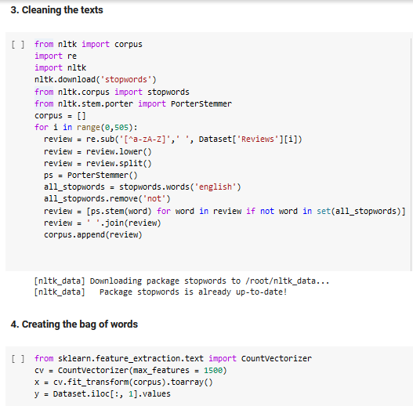
- Splitting the dataset into training and testing sets and then training the model using the GaussianNB naïve_bayes model.
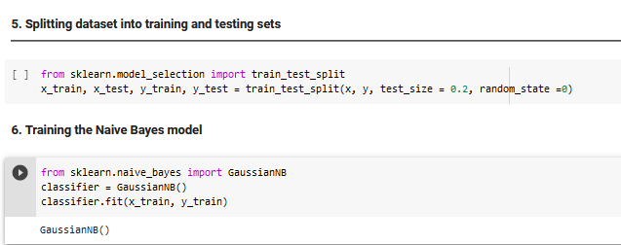
- Predicting the test results
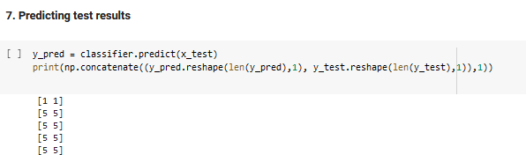
- Creating the confusion matrix and computing the accuracy score.
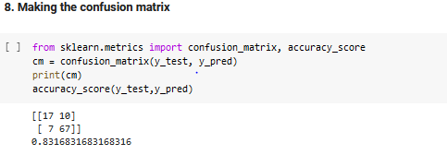
The predictive analysis using python produced a model that is 83% accurate in making sentiment analysis and prediction. I used 80% of the available data to train the model and the other 20% to test its accuracy. Clearly there is still room for improvement on this accuracy level by carrying out more data cleaning tasks. This model is useful as it forms part of the components of the CSS data-flow process. Negative predictions made by the model are forwarded to support agents for them to offer further assistance to the aggrieved customers whereas the positive ones are stored for further analysis into what ‘good’ things the Sacco is doing that the customers are happy about.

Appendix 1: The CSS Architectural Design

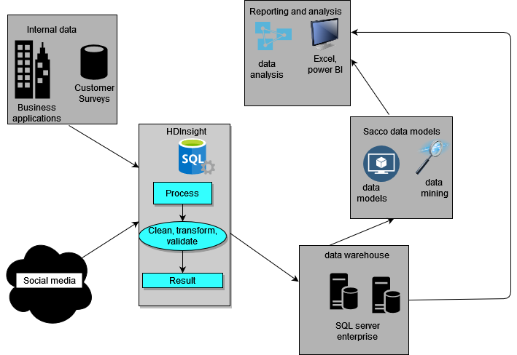

APPENDIX 2: MongoDB

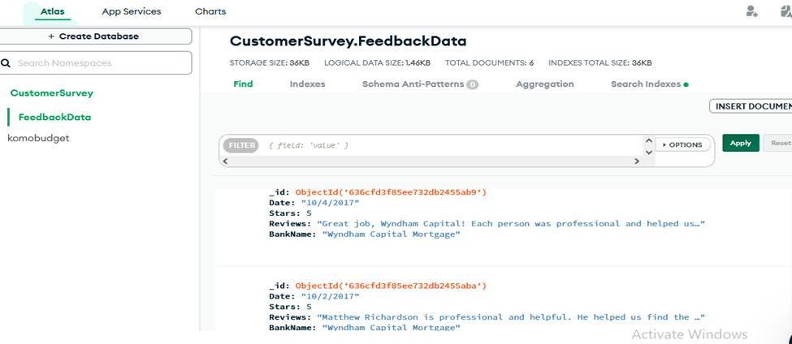

APPENDIX 3. DATA FLOW DIAGRAM

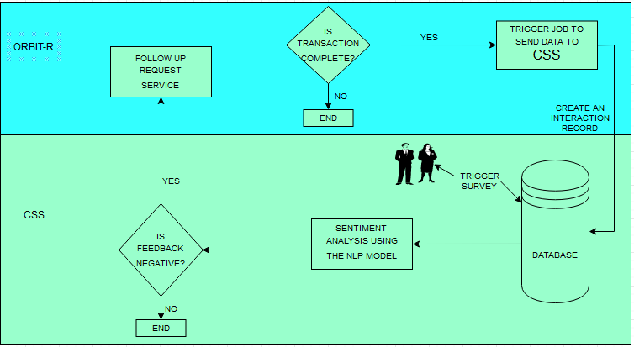

References
Agrawal, A. (2021, June 25). Closing the Experience Gap with Customers using S/4 HANA and Qualtrics. https://blogs.sap.com/2021/06/25/closing-the-experience-gap-with-customers-using-s-4-hana-and-qualtrics/
Akshay, P. (2018, February 16). NoSQL Data Architecture & Data Governance: Everything You Need to Know. https://www.dataversity.net/nosql-data-architecture-data-governance-everything-need-know/
Christopher A, Mick P., Frederick G. (2017). Effects of Mobile versus PC Web on Survey Response Quality: A Crossover Experiment in a Probability Web Panel, Public Opinion Quarterly. Volume 81. Issue S1. Pages 280–306. https://doi.org/10.1093/poq/nfw088.
Brian, K. (2019, Aug 27). How to handle service downtime in the cloud age. https://www.techtarget.com/searchwindowsserver/tip/How-to-handle-service-downtime-in-the-cloud-age
Business Daily. (2016, October 21). Supermarket Employees’ SACCO Targets Shoppers with Loans in Membership drive.https://www.businessdailyafrica.com/bd/economy/supermarket-employees-sacco-targets-shoppers-with-loans-in-membership-drive-2130016
Dennis, Robert & Gambhir, Shweta. (2000). Internet Question and Answer (iQ&A): a Web-based survey technology. IEEE transactions on information technology in biomedicine: a publication of the IEEE Engineering in Medicine and Biology Society. 4. 116-25. 10.1109/4233.845204.
Geetcloud. (2021, Sep 04). Azure Cosmos DB | Mongo DB - Embedding vs Reference. https://dev.to/geetcloud/azure-cosmos-db-mongo-db-embedding-vs-reference-81p
Jake, F. (2020, November 11). General Data Protection Regulation (GDPR) Definition and Meaning. https://www.investopedia.com/terms/g/general-data-protection-regulation-gdpr.asp#toc-understanding-the-general-data-protection-regulation-gdpr
Kuul, M. (2020, April 03). Integrating SAP Marketing Cloud with Qualtrics XM Platform to enrich campaign execution with experience data. https://blogs.sap.com/2020/04/03/integrating-sap-marketing-cloud-with-qualtrics-xm-platform-to-enrich-campaign-execution-with-experience-data/
Law Insider. (n.d). Trade Secrets and Confidential Information Sample Clauses. https://www.lawinsider.com/clause/trade-secrets-and-confidential-information
Microsoft. (2022). Data modeling in Azure Cosmos DB. https://learn.microsoft.com/en-us/azure/cosmos-db/nosql/modeling-data
Microsoft. (2022). Non-relational data and NoSQL. https://learn.microsoft.com/en-us/azure/architecture/data-guide/big-data/non-relational-data
Microsoft. (2016, April 07). Understanding Microsoft Big Data Solutions. https://learn.microsoft.com/en-us/previous-versions/msp-n-p/dn749804(v=pandp.10)
Mehdi, F. (2022, July 26). Schema Design and Relationship in NoSQL Document-based databases. https://blog.usu.com/en-us/schema-design-and-relationship-in-nosql-document-based-databases
Paul, M. & Vicki, G. (2002). How Surveys Influence Customers. https://hbr.org/2002/05/how-surveys-influence-customers
Repustate. (2021, Dec 16). Sources of Customer Experience Insights. https://www.repustate.com/blog/customer-experience-data-sources/

Microsoft. (2016, April 04). Use case 3: ETL automation. https://learn.microsoft.com/en-us/previous-versions/msp-n-p/dn749805(v=pandp.10)
Microsoft. (2022, September 22). What is Azure HDInsight? https://learn.microsoft.com/en-us/azure/hdinsight/hdinsight-overview

